Introduction to Molecular Modeling

In the following laboratory activities you will examine three-dimensional models of molecules using the computer-based molecular viewing program called Jmol.* You can access a version of Jmol for use with these activities at http://cheminfo.chem.ou.edu/~mra/home.html.

Instructions:

After obtaining access to the Jmol program you should see an image on your computer screen that looks similar to the following figure.

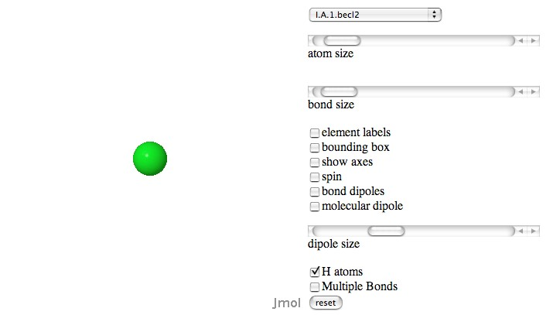

You can view the molecules you will need for the following activities through the drop down menu on the upper right of your screen. The names of the molecules are labeled so that they correspond to the activities. So, for example the molecules for the I. VSPER activities are labeled with a “I.” All of the molecules are labeled by number and alphabet in outline form and listed in order to make them easy to find.

* Jmol is a free, open source molecule viewer for students, educators, and researchers in chemistry and biochemistry. It is cross-platform, running on Windows, Mac OS X, and Linux/Unix systems (see: http://jmol.sourceforge.net/). A team of researchers are updating and improving the program on a constant basis. Robert Hanson of St Olaf College has been particularly helpful to the authors of these activities.

As an example, let’s open the file for methane, CH₄. It can be found in the Jmol menu list as I.C.1.ch4. Highlight the molecule in the list and then click. The molecule window should now be showing the CH₄ molecule:

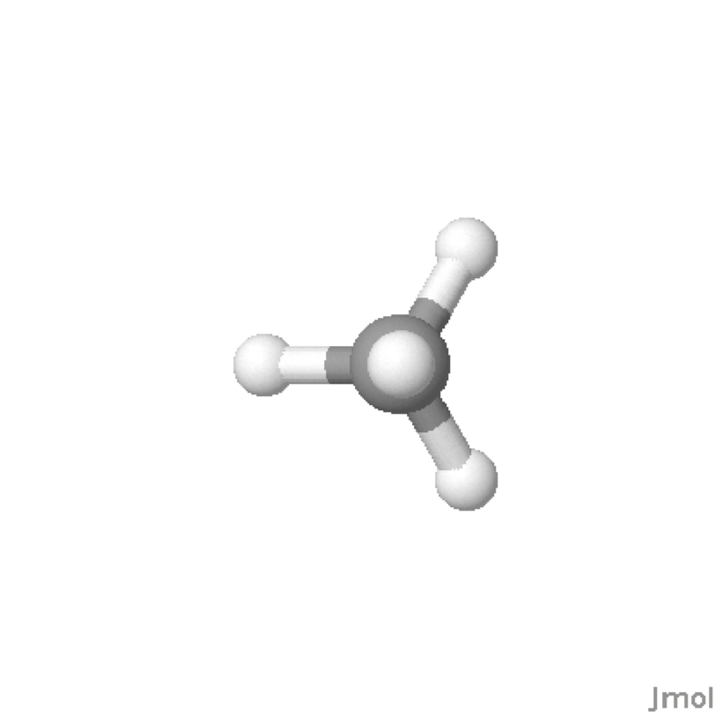
You can now interact with the molecule in a number of different ways. To rotate the molecule, click anywhere in the window and drag your mouse around. You can rotate the molecule in the plane of the screen and resize it by using the shift key when you click/drag the mouse side by side or up and down.

There are a number of different ways of viewing the molecule. The Jmol window has a number of operations that can be utilized by a click box or slider bar. These include: slider bars to control atom and bond size, click boxes to label the atoms, superimpose bounding boxes, add axes, spin the molecule, and add bond and molecule dipoles. Try each function out to see how it affects the molecule. In addition you can access a number of other functions by control clicking” (mac) or right clicking (pc) in the molecule window.
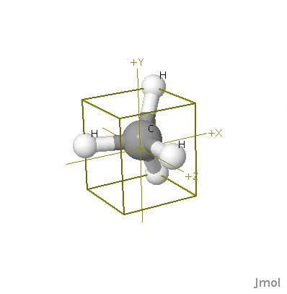

To measure a bond length, hold the cursor over an atom until an atom label appears. Double click on the atoms. A plus sign should replace the cursor arrow. As you move the plus sign to another atom a colored dotted line should appear. When you place the cursor over a second atom double click on it when the atom label appears. The colored line should change color and a value for the length should appear. Jmol seems to be a little sensitive to this operation so you might have to try this several times.

To measure a bond angle, double click on one of the end atoms when the atom label appears. Then drag the plus cursor to the middle atom in the angle. Single click on this atom when the atom label appears and then move the cursor to the other end atom and double click when the atom label appears. The angle in degrees should appear as the dotted line changes color.

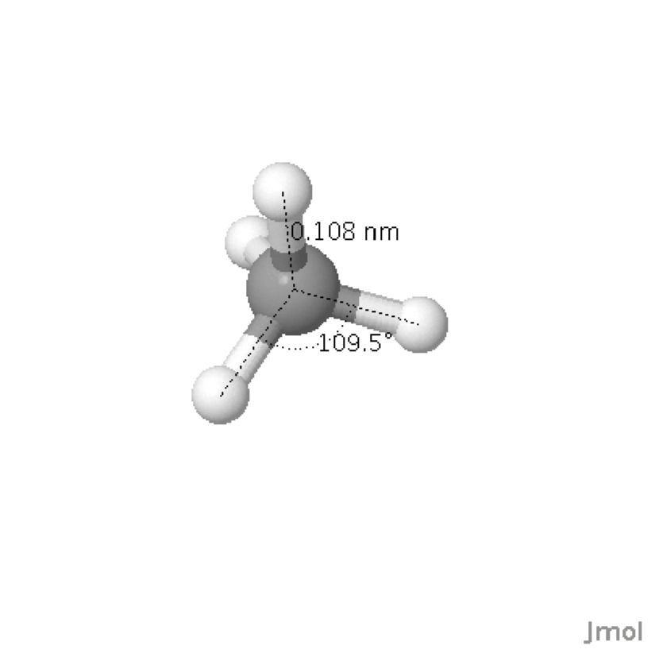

If you want to compare two or more molecules, you can open additional browser windows.

VSEPR

Name________________________________ Lab Section___________________________

For this activity, all of the file labels will begin with a roman numeral I. Each of the questions asks you to examine molecules that are designated with letters. For example, for part A, all of the molecule files will be labeled I.A.

It may be helpful for you to refer to the table of molecular geometries found in most general chemistry textbooks.

- Using Jmol, examine the two molecules labeled I.A. Write the molecular formula for each molecule. Draw and label the molecules and measure and record their bond angles.
- BeCl₂

Bond angle; 180 degrees
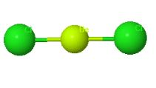
- CO₂
Bond angle; 180 degrees
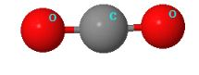

- Using Jmol, examine the two molecules labeled I.B. Write the molecular formula for each molecule. Draw and label these molecules and measure and record their bond angles. Draw the Lewis structure for each molecule. Why is SO₂ shaped like it is and is not linear? How is it different from the molecules in section A? What is similar about all of the molecules in List B? Describe any difference between the angles you measure and the theoretical ones (see your textbook to see what the theoretically expected angles should be.)

BF₃
Bond angle; 120 degrees

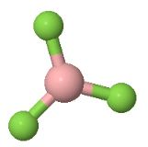
Lewis structure
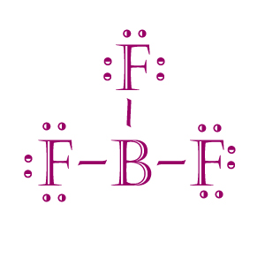

SO₂
Bond angle 118.7 degree
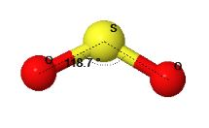
Lewis structure
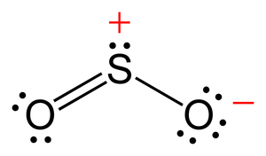
Without any linear assumption, SO₂ bonds are straight as that of the molecules in section A.

- Repeat step B for the three molecules labeled I. C. (i.e. open them, measure their bond angles, and draw the Lewis Structures). Write the molecular formula for each molecule. What is similar about all of the molecules in List C? Compare the actual bond angles with the theoretically expected angles. Explain any trend in bond angles that you observe.

CH₄

Bond angle: 109.5 degrees
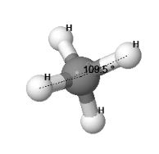

Lewis structure
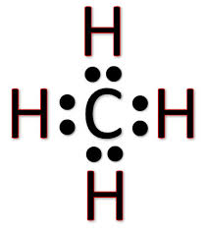

NH₃
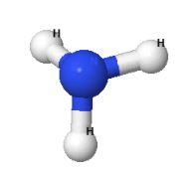
Bond angle: 107.7 degrees
Lewis structure
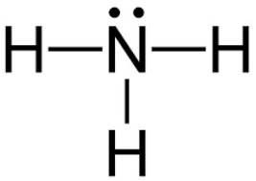

Similarities:
Both molecules are made up of hydrogen atoms
The atoms are bound together by strong covalent bonds

Comparing actual and theoretical angles:
Consider the molecule of methane CH4 with "ideal" 109.5 angles; unshared electron pairs in NH3 (one) and in H2O (two) are closer to the sp3 central atom and interact differently with the rest of bonded electrons. The interaction is the electrostatic repulsion - the unshared electron pairs "need more space" so less demanding bonded orbitals getting proportionally closer (smaller angles) to each other (less repulsing).

- All of the five molecules Labeled I.D. have five regions of electron density around the central atom. Open the I.D.1.pf5 molecule, and examine the two different FPF angles in the molecule. Draw and label this molecule. Predict where the lone pairs will go in molecules that have one, two, and three lone pairs. Now, open the other files, write the molecular formula for each molecule, measure their bond angles, and draw the molecules. Were your predictions correct? At what locations do the lone pairs go in five coordinate molecules?
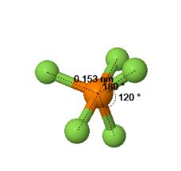
The two different angles are 120 and 180 degrees.
Predicting where the lone pairs will go, this comes out to be 5(0 lone pair + 5 sigma bonds) it means there are 5 hybridized orbital. Thus the hybridization comes out to be sp3d

SF₄
Bond angles: 87.4 and 171.6 degrees
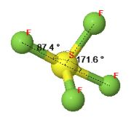

ClF₃
Bond angles; 87 and 174.1 degrees
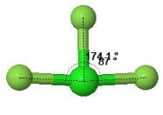
XeF₂
Bond angle 180 degrees
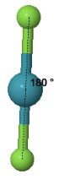
i₃₋
Bond angle 180 degrees
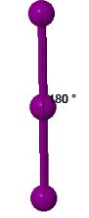

- Using Jmol, examine the three molecules labeled I.E., all of which have six regions of electron density. Write the molecular formula for each molecule. Draw the molecules and measure their bond angles. Draw the Lewis structure for each molecule. How do nonbonding (lone pair - LP) electrons explain the molecular geometries of XeF₄ and IF5? Explain any differences you notice between the theoretically expected bond angles and your observed values.
  - SF₆
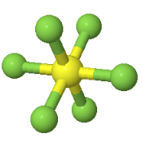
Bond angle; 90 degrees

Lewis structure
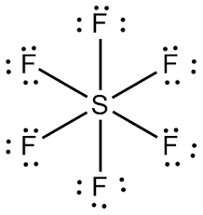

IF₅
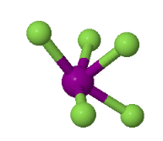
Bond angle; 88.1 degrees

Lewis structure
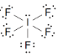

XeF₄
Bond angle; 88.1 degrees
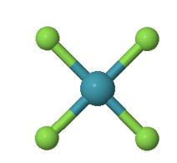
Lewis structure

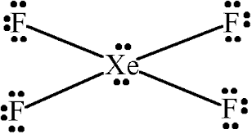

The geometry of XeF₄ is square planar with symmetric electron region distribution hence a nonpolar, whereas the molecular geometry of IF₅ is square pyramidal with asymmetric charge distribution on the central atom hence a polar.

Carbon Compounds

Name________________________________ Lab Section___________________________

For this activity, all of the file labels will begin with a roman numeral II.

- Bond Types

  - In Jmol, open the II.A.1, II.A.2, and II.A.3 molecules. Measure and record the carbon-to-carbon bond lengths for single (CH3CH3), double (CH2CH2), and triple (CHCH) bonds. Make a generalization comparing the lengths of single, double, and triple bonds. Propose a reason for your generalization.

Carbon to Carbon lengths for:
CH3CH3 is 0.152nm
CH2CH2 is 0.133nm
CHCH is 0.119nm

As the number of carbon to hydrogen bonds increase, the carbon atoms are help far from one another.

  - Draw the Lewis structure for benzene - C6H6 - and predict the carbon-to-carbon bond lengths in the molecule. Using Jmol, open II.A.4, the benzene molecule (C6H6), and measure the carbon-to-carbon bond lengths. Is your prediction correct? Compare the bond lengths in benzene to those of the single, double and triple bond in section A.1. Does benzene contain single and/or double C-C bonds? Why? How do you explain you observations?

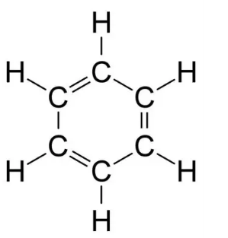

0.134nm
The "single" bonds in benzene involve the overlap of sp2-sp2spX2-spX2 orbitals, whereas alkane single bonds involve the overlap of sp3-sp3spX3-spX3 orbitals. This leads to the former bonds being shorter.

Using jmol, the c-c length; 0141nm
My prediction was no exact but nearly correct.
Comparing:
Benzene contains 3 double C-C bonds just like ethylene’s single C-C bond.

- Cyclic Compounds

In Jmol, open the three six carbon cyclic structures in II.B.1, II.B.2, and II.B.3. Compare and contrast these molecules. Focus on the C-C bond types and the geometries of these compounds.

C₆H₁₂.1
Geometry: Tetrahedral, trigonal planar for alkene carbon atoms.
These molecules have single carbon to carbon bonds irrespective of C₆H₆.
C₆H₆
Geometry: Trigonal planar.
C₆H₁₂.2
Geometry: Tetrahedral, trigonal planar for alkene carbon atoms.

- Summary

From A and B, what relationship did you find between (carbon-to-carbon) bond types and molecular geometries?
All the carbon bonds of the individual molecules have similar distances between them but different bonding angles. The distance between C-C bonds is 0.155 nm.

